Expected mess ups.  
  
The jlcpcb view reverse polarised my IR leds

Will have to desolder

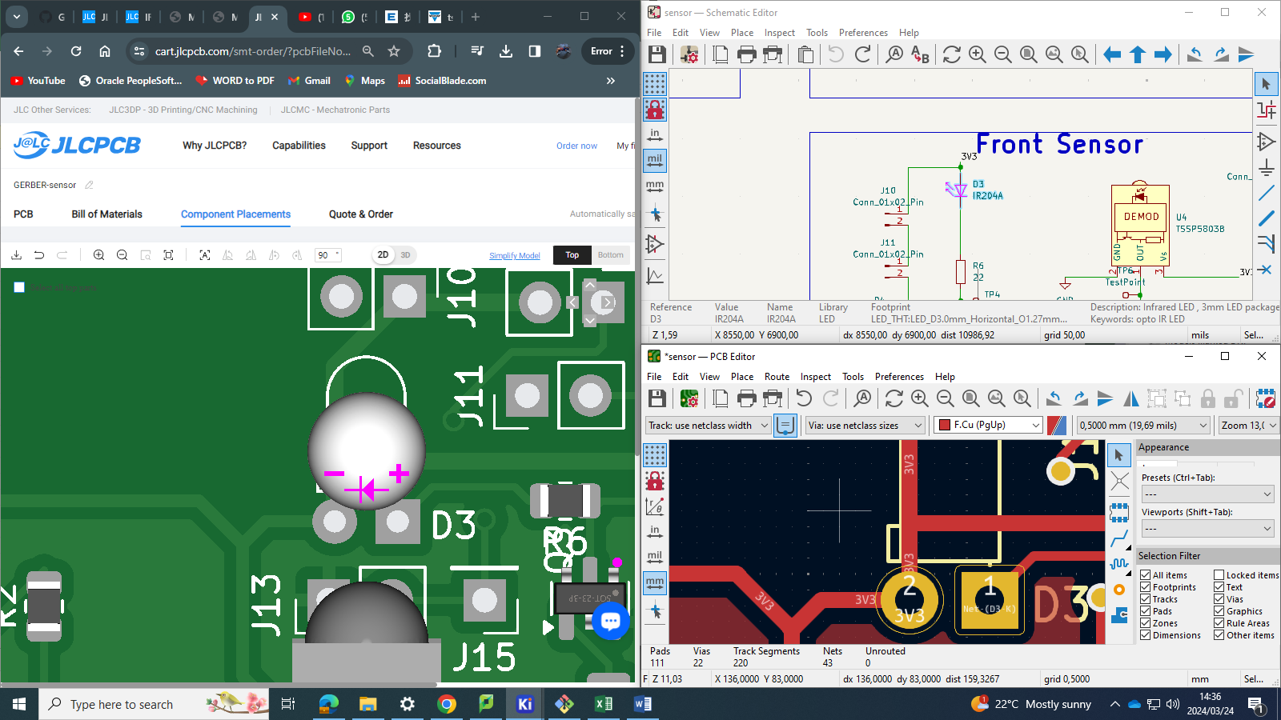

Final pcb

